OpenStreetMap Israel Data Wrangling with MongoDB

OSM Dataset

The reason why I pick Israel is because in this 8,019 mi² country. Jerusalem would be the place I picked ultimately in this project because contains geographically diverse features within its relatively small area and also the most arguable religions history. From Judaism, Islam, Christianity and Druzism.

I would like to explore this map datasets to learn more about the local religion sites as well as other amenties.

Data scoure:

http://www.openstreetmap.org/relation/1473946

http://wiki.openstreetmap.org/wiki/WikiProject_Israel

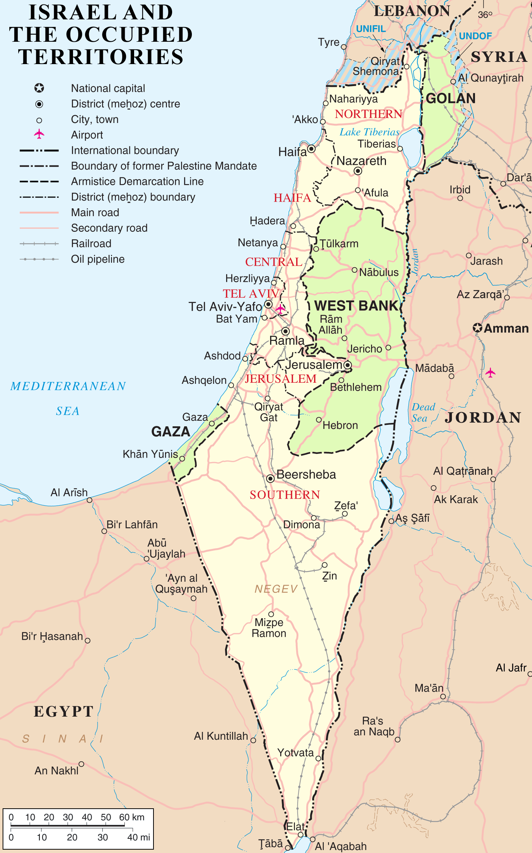

{'bounds': 1, 'member': 3881, 'nd': 716073, 'node': 645370, 'osm': 1, 'relation': 535, 'tag': 177384, 'way': 65316}

There are none problemchars. In this finding which is awesome. {'lower': 120538, 'lower_colon': 43343, 'other': 13503, 'problemchars': 0}

counter = 10

for _, element in ET.iterparse('jerusalem_israel.osm'):

temp_dict = {}

flag = 0

for tag in element.iter('tag'):

key = tag.attrib['k']

# temp_dict[key] = tag.attrib['v']

if (key.startswith('religion')):

print('{0}: {1}\n'.format(key, tag.attrib['v'].encode('utf-8')))

counter = counter - 1

if (counter == 0):

break

religion: christian

religion: christian

religion: muslim

religion: muslim

religion: muslim

religion: muslim

religion: christian

religion: christian

religion: christian

religion: christian

counter = 10

for _, element in ET.iterparse('jerusalem_israel.osm'):

temp_dict = {}

flag = 0

for tag in element.iter('tag'):

key = tag.attrib['k']

# temp_dict[key] = tag.attrib['v']

if (key.startswith('service')):

print('{0}: {1}\n'.format(key, tag.attrib['v'].encode('utf-8')))

counter = counter - 1

if (counter == 0):

break

service: press service: press service: tyres service: tyres service: bus service: bus service: bus service: bus service: bus service: bus